TC-REF-004
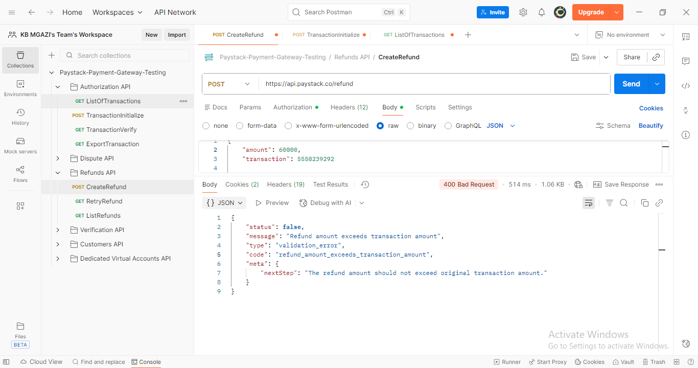
Request:
{
"amount": 60000,
"transaction": 5550239292

}

Response:
{
"status": false,
"message": "Refund amount exceeds transaction amount",
"type": "validation_error",
"code": "refund_amount_exceeds_transaction_amount",
"meta": {
"nextStep": "The refund amount should not exceed original transaction amount."
}
}

